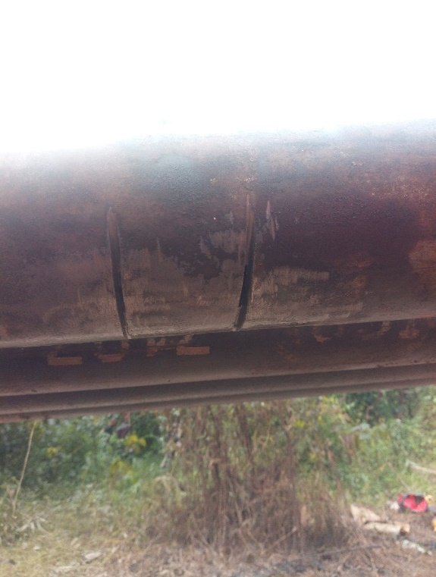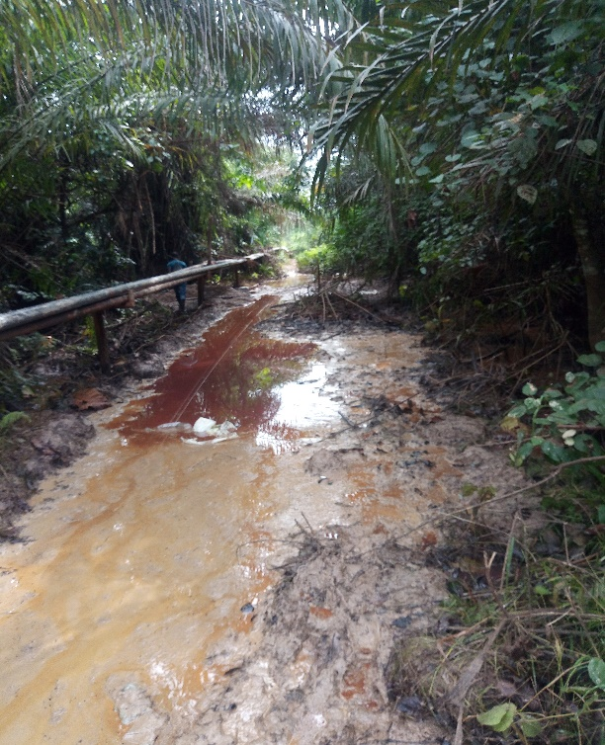

Figure 1. spill points indicated by an arrow Figure 2. Impacted area from spill

